Title of the Paper (Times New Roman Font, Size 12pt, Title Case, Bold Face, Center)

First Author^{#1}, Second Author^{*2}, Third Author^{#3}
#First-Third Department, First-Third University
Address Including Country Name
¹first.author@first-third.edu
³third.author@first-third.edu
*Second Company
Address Including Country Name
²second.author@second.com

Abstract
A brief abstract of the research work not more than 250 words in length should be typed here. (Times Roman Font, Size 9 pt., Single spacing, Italic). The abstract should be self-contained and understandable by the general reader outside the context of the article. It should be free from formulae, acronyms and references.
Keywords - component; formatting; style; styling; insert (key words)
- Introduction
Authors should submit an electronic version of the paper corresponding to the abstract previously accepted at the CLIMA2016 website http://www.clima2016.org. Please use this document as the template to your paper. The accepted format is unlocked Portable Document Format (PDF) and the file should not exceed 1 Mbyte.
No more than 2 levels of headings should be used. Use predefined text styles in this template. The paper with a dimension up to 10 pages should be formatted as follows. The main text and minimum font size within all figures is 10 pt.
Major headings should be left-justified 10 pt bold face, and sub-headings appear left-justified on a separate line in 10 pt bold face.
- Ease of Use
First, confirm that you have the correct template for your paper size. This template has been tailored for output on the A5 paper size an ISO 216 international standard paper size, which measures 210 mm x 148 mm. Please use only this paper size.
The template is used to format your paper and style the text. All margins, line spaces, and text fonts are prescribed. Please do not alter them.
- Prepare Your Paper Before Styling
Before you begin to format your paper, first write and save the content as a separate text file. Keep your text and graphic files separate until after the text has been formatted and styled. Do not use hard tabs, and limit use of hard returns to only one return at the end of a paragraph. Do not add any kind of pagination anywhere in the paper.
Finally, complete content and organizational editing before formatting. Please take note of the following items when proofreading spelling and grammar:
- Do not mix complete spellings and abbreviations of units: “kWh/m²” or “kilowatt-hour per square meter”, not “kilowatt-hour/m²”. Spell out units when they appear in text: “. . . a few henries”, not “. . . a few H”.
- Use a zero before decimal points: “0.25”, not “.25”. Use “cm³”, not “cc”.
- Every word in a title must be capitalized except for short minor words such as “a”, “an”, “and”, “as”, “at”, “by”, “for”, “from”, “if”, “in”, “into”, “on”, “or”, “of”, “the”, “to”, “with”.
- Equations
The equations are an exception to the prescribed specifications of this template. To create multileveled equations, it may be necessary to treat the equation as a graphic and insert it into the text after your paper is styled.
Number equations consecutively. Equation numbers, within parentheses, are to position flush right, as in (1), using a right tab stop. To make your equations more compact, you may use the solidus ( / ), the exp function, or appropriate exponents. Punctuate equations with commas or periods when they are part of a sentence, as in
           
Note that the equation is centered using a center tab stop. Be sure that the symbols in your equation have been defined before or immediately following the equation. Use “(1)”, not “Eq. (1)” or “equation (1)”, except at the beginning of a sentence: “Equation (1) is . . .”
- Figures and Tables
Figures and tables must be centred. Graphics may be full color. All colors will be retained on a digital medium. Graphics must not use stipple fill patterns because they may not be reproduced properly. Please use only SOLID FILL colors which contrast well both on screen and on a black-and-white hardcopy, as shown in Fig. 1.
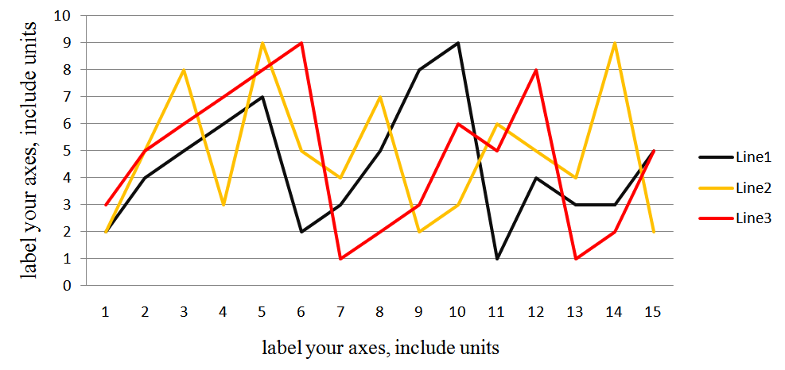
Fig. 1 A sample line graph using colors which contrast well both on screen and on a black-and-white hardcopy
Check that the resolution is adequate to reveal the important detail in the figure. Check all figures in your paper both on screen and on a black-and-white hardcopy. When you check your paper on a black-and-white hardcopy, please ensure that:
- the colors used in each figure contrast well,
- the image used in each figure is clear,
- all text labels in each figure are legible.
Figures must be numbered using Arabic numerals. Figure captions must be in 8 pt Regular font. Tables must be numbered using Arabic numerals. Table captions must be centred and in Regular font. Tables must be provided as close as possible to their reference in the text. Tables and their heading should be centrally aligned. A sample is shown in Table 1.
Table 1. Example table
 | Title | Abstract | Main text
Face style | Bold | Italics | Normal
Size | 12 pt | 9 pt | 10 pt
Acknowledgment
The heading of the Acknowledgment section and the References section must not be numbered. All reference items must be in 8 pt font. Please use Regular and Italic styles to distinguish different fields as shown in the References section. Number the reference items consecutively in square brackets (e.g. [1]).
References
[1] A. Author and C. Corresponding. Title of the article. J. Irreprod. Res. 46 (1997) 140–145.
[2] A. Nonymous. Article in proceedings. In: J. Jones and B. B. Bones, eds. Proc. 156 Int. Conf. on Writing Abstracts, pp. 10–16, Seatown, Waterland, 1-4 April 1989. Publisher.

